Java Portfolio of my project “GCD”.

Date: May 22, 2023

What is it: I wrote a program that’s really helpful on math, it comes handy whenever I need to find the greatest common divisor of two numbers.

Source code: gcd.java

import java.util.Scanner;

public class gcd{

public static void main(String[]args){

Scanner inp= new Scanner(System.in);

System.out.println("This is a program that helps to find GCD.");

System.out.println("Type \"quit\" to quit the GCD calculator.");

boolean quit=false;

while(true){

int gcd=1, i=1;

System.out.println("Type in two integers to find their greatest common divisor: ");

int n1=inp.nextInt();

int n2=inp.nextInt();

do{

if(n1%i==0 && n2%i==0)

gcd=i;

i++;

}while(i<=n1 && i<=n2);

System.out.println("GCD of "+n1+" and "+n2+" is "+ gcd+".");

}

}//main

}//class

How it goes:

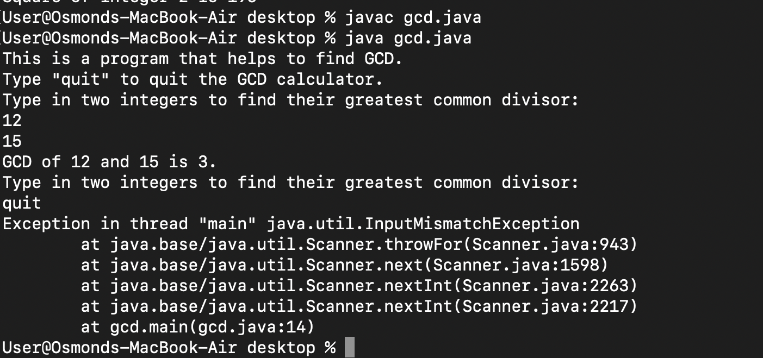

Bug: Whenever I typed “quit” to end the program itself, it occurred some compile error, and I believed that the error happened because I didn’t set the correct data type for “quit”. It should be a string, not an integer.

A RENEWED program:

What I have learned:

1. Knowing how to find GCD using Java in three different loops, including for loop, do while, and while loop.
2. Being aware of the difference between three different types of loops and the application of infinite loops.
3. Using Boolean data type to decide whether the program can continue or not.